NRCH Annual Action Plan
2021 - 2022

NRCH

NRCH completed a restructure of the Health Promotion functions in the 2020/2021 financial year, which included some new positions, reporting lines and further enhancement of health promotion integration across the entire service. The Health Promotion functions are now within a new program area, titled Healthy Communities, which report directly to the Executive Manager Community Services and Consumer Empowerment. This restructure has positively impacted IHP.
Healthy Communities is inclusive of three new positions, including an Aboriginal Health Worker and Health Promotion Concierges. These positions are specifically allocated to employ community members of the City of Yarra in which we work.

Vision for Integrated Health Promotion

To nurture and build a healthy community through evidence-based health promotion and prevention projects.

Using strength-based principles, NRCH is working with the community to create a place where each person feels that they belong, has meaningful connections to others, feels safe to be themselves and can get the support they need to live a healthy life.

Principles

Six key principles, which are within our scope, underpin this Strategic Integrated Health Promotion (IHP) Plan:

Working at scale: By working collaboratively and in partnerships, our strategies, goals and objectives are intended to achieve longer-term outcomes for sustainability in population health improvements.
Evidence-informed priorities and collaborative planning: This Plan is based on evidence available about health is in alignment with those of government and local partners. One of the outcomes of this approach to planning is to inform future shared strategic planning in 2021-25 across the City of Yarra which will further create collaborative methods of working.
Inequities and the determinants of health: We recognise that the determinants of health influence the health status, behaviours and social issues of all individuals and populations. With our partners, we seek to impact those determinants we can influence. Therefore, while all the programs and projects aim to improve the health and wellbeing of the whole population, more focus is given to supporting vulnerable population groups such as newly arrived migrants, people from Culturally and Linguistically Diverse backgrounds, Aboriginal and Torres Strait Islander people, and communities living in socially disadvantaged locations such as the North Richmond housing estate.
Co-design and community engagement: We recognise that for health promotion work to be effective and sustainable, our communities must be engaged as active partners
and stakeholders. NRCH uses the “Concierge model” and this is evident in the employment of Health Promotion Concierges from our public housing estates.

Partnerships and places: We recognise that the work of health promotion and prevention requires strong partnerships working to mutually reinforce the strategies and actions which will deliver outcomes. Working in partnerships enables the maximising of partner resources by leveraging expertise and by implementing mutually reinforcing activities to generate improvements in health outcomes.
Systems change: By looking through the lens of systems change, we will increasingly understand the dynamics of prevention practice across populations and the linkages and relationships necessary to intervene effectively. We acknowledge that complex problems require solutions based on partnerships, engaged communities, mutually reinforcing activities and scaled up actions.

Policy and Planning context
Table 1 demonstrates a transparent line of sight to the policy and planning context at state and regional levels for the work of NRCH’s health promotion and prevention
work.

These show that our Integrated Health Promotion priorities for 2021-2025 align with the Victorian public health and wellbeing plan 2019 -2023 priorities, the Municipal public health and wellbeing plan of the City of Yarra and the health promotion and prevention priorities of our key partners.
This Strategic IHP plan is building on priorities and partnerships that are established so the alignment of our work will deliver an integrated approach to health promotion
across North Richmond Community Health’s catchment.

It is critical for health outcomes to ensure that our efforts are aligned not only with external partners but also across NRCH. Our Integrated Health Promotion work will be strengthened by the health services work undertaken across other areas of the organisation (e.g. Allied Health and Dental), which work along the continuum from primary prevention through to early intervention and chronic disease care.
Table 1. Alignment documents

National Level | - Australia’s Long Term National Health  Plan 2019-2030.
State Level | - Victorian public health and wellbeing plan 2019-2023.  - Korin Korin Balit-Djak – Aboriginal Health, Wellbeing and Safety Strategic  Plan 2017-2027.
LGA Level | - Municipal Public Health and Wellbeing  Plan 2021-2025 (City of Yarra)

Community engagement
This diagram represents NRCH’s Community Engagement Strategy with community at the centre and co-deign being our core principle when delivering Health Promotion.

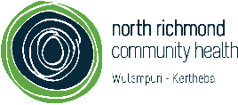
Community Engagement Strategy: Community-lead and co-designed

Future Directions:
Community Engagement Strategy:
  - Community Engagement Policy
  - Community Engagement Plan (Connecting to our service
users and community by listening, learning, involving, and empowering community)

Community Engagement Model:

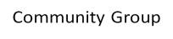
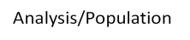
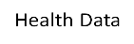
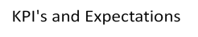
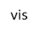
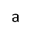
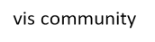
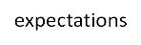
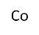
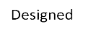
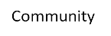
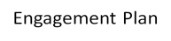

Our priorities

Mental health and wellbeing

When considering mental health illness and professional help rates, diagnosis with anxiety and depression in the City of Yarra (CoY) were close to the Victorian state average³, however, seeking help for a mental health issue was higher for both men and women in the CoY when compared to the Victorian state average as shown in table 3.
The COVID-19 pandemic has undoubtedly exacerbated pre-existing inequities within disadvantaged communities. The latest studies have shown that exclusion of disadvantaged communities has left many feeling an increased feeling of stress and anxiety¹. VicHealth reports that 39% of people who don’t speak English as a first language have reported significant difficulty with mental health issues and social connection².
The local community in North Richmond predominantly comprises of people who are from a Culturally and Linguistically Diverse Background (CALD) with a high percentage of people born overseas as presented in table 2.
According to recent data shared by the Department of Families, Fairness and Housing (DFFH), public housing estate residents of North Richmond utilise mental health services six times more than other Victorians.
This priority aligns with the improving mental wellbeing priority, which is a focus area in both The Victorian Public Health and Wellbeing Plan 2019-2023 and the CoY’s Municipal Public Health and Wellbeing Plan. NRCH have been a key partner in the CoY’s planning process through a series of consultations and workshops and mental wellbeing was always flagged to be one of the most pressing priority areas by other Community Health Organisations along with NRCH.

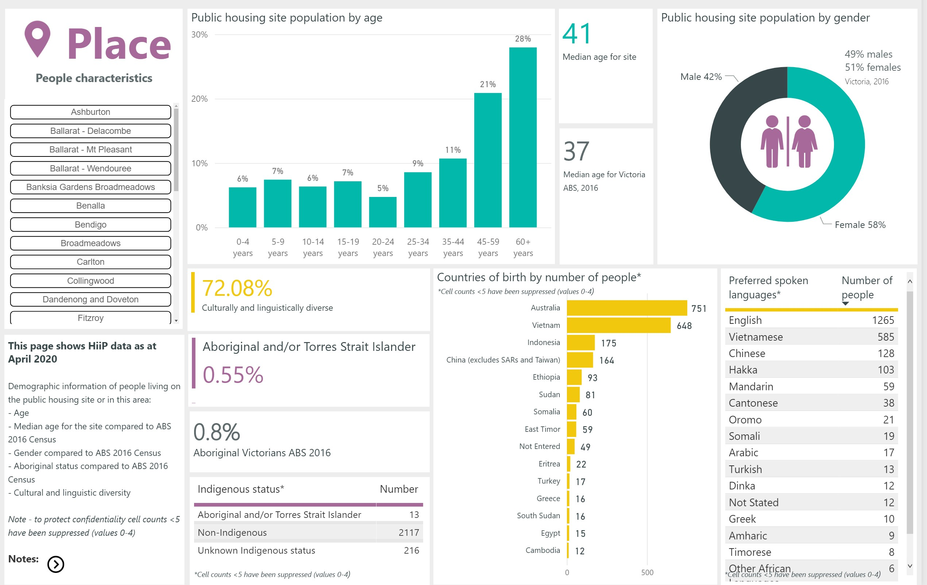
Table 2. North Richmond public housing estate demographics.

Table 3. Mental illness and professional help rates in the City of Yarra and Victoria.
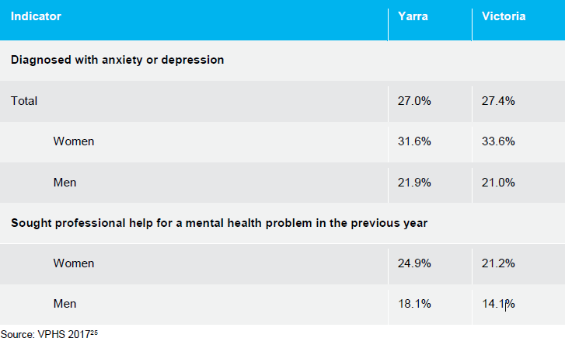

Physical Wellbeing

According to the Victoria Population Health Survey conducted in 2017, the City of Yarra had good fruit and vegetable intake when compared with the Victorian average⁴. Further, the same can be seen when considering take-away and sugar sweetened beverage consumption as displayed in table 4 and table 5 below.

Table 4. Fruit and Vegetable consumption in City of Yarra compared to the Victorian average in people aged 18 years and above.

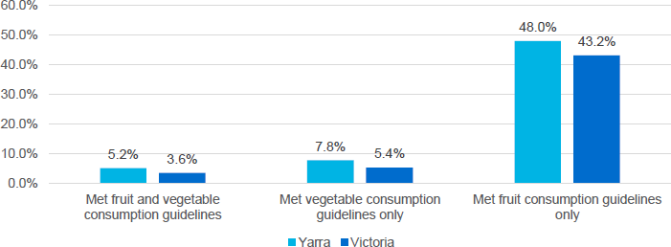

Table 5. Takeaway and sugar sweetened beverage rates in the City of Yarra compared to the Victorian average in people aged 18 years and above.
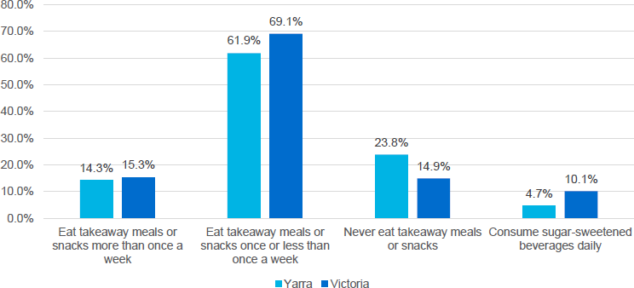

The Covid-19 pandemic and associated lockdowns across Victoria have had a significant impact on food systems and Victorian people’s access to certain foods.

In 2020, there was a 40% increase in demand of food relief and 28% increase in people facing food insecurity for the first time which was more pronounced in disadvantaged communities such as public housing residents ⁵. NRCH in partnership with Belgium Avenue Neighbourhood House (BANH) have had and continue to have a pivotal role in providing food relief to housing estate residents and the wider community.

A recent VicHealth study found that physical activity had also been impacted by lockdowns and COVID-19 restrictions with the main barrier in the CoY being low motivation to exercise (39%)⁶. A survey of the public housing estates of Richmond, Collingwood, and Fitzroy found that the majority of residents of these estates would be more physically active if they had more opportunities to participate in planned physical activity exercises. The Heart Foundation also reported that people did significantly less physical activity during lockdown and raised concerns that this may continue post lockdown⁷.

Reconciliation

The City of Yarra, especially the suburbs of Fitzroy, Collingwood, and Richmond carry a significant history for the Aboriginal community living in these areas. Many key Aboriginal organizations run in the City of Yarra e.g. Victorian Aboriginal Health Service⁸.
The last census recorded almost 400 Aboriginal and Torres Strait Islander people living in the City of Yarra. Further, this is the highest number recorded over a 20-year period and amounts to almost 0.4% of the residents of the City of Yarra⁹. When considering NRCH, as seen in table 2 above 0.5% of public house estate residents identify as Aboriginal or Torres Strait Islander. While this percentage is accurate regarding those living in public house dwellings, in North Richmond there is a significantly higher number of Aboriginal and Torres strait Islanders who use NRCH services or live rough around NRCH’s premises.
In June 2020 during the peak of the pandemic VicHealth found that in comparison with the Victorian average, Aboriginal or Torres Strait Islander people experienced higher rates of: High psychological distress (28%), financial hardship (74%), risk of short-term harm from alcohol (48%), daily sugary drink consumption (80%), and running out of food and being unable to afford more (46%)².

Lenses

The health promotion team at NRCH will be applying the following lenses across all our health promotion activities/projects in different priority areas. These lenses are gender equity and climate change.

Gender Equity:

NRCH is part of the Building a Respectful Community (BRC) Partnership which is coordinated by Women’s Health in the North (WHIN). Working with this partnership and different external stakeholders we will leverage off existing gender equity frameworks e.g. Change the story. Which we will consider when planning and developing our projects ensuring we are aligning our work with contemporary evidence. While Preventing Violence Against Women (PVAW) is not a standalone priority, we will take part in key campaigns such as Week Without Violence and 16 days of activism, build the capacity of staff and volunteers in this area and ensure we are applying a gender-neutral lens in the work we deliver with our community.

Climate Change:

The health promotion team works and will continue to work closely with NRCH’s Food Project Coordinator in making NRCH’s café sustainable. We will also be working with Cultivating Community on food projects for our community and climate change will be at the centre of this work. The Achievement Program has climate changes resources which the health promotion team will use to evaluate the work we do in this space.

Planning and Reporting table

Focus Area | 1.1 Mental Health and Wellbeing
Target Population Groups & Settings | The residents of the City of Yarra.  Local community leaders and religious faith leaders.
Plan |  | Report
Objective(s) | - Increase mental health awareness and literacy.  - Build capacity of local mental health service providers.  - Improve access to services including referral pathways.  - Deliver mental health promotion, prevention and engagement activities.  - Increase referrals from NRCH services into health promotion and social inclusion activities (social prescribing). | What was achieved?  Report on measures provided for each focus area (including changes in 12 months).
Target | - At least 100 of residents receive training in mental health and wellbeing training.  - Ten community members qualified to deliver MHFA training.  - Document and improve access to health and wellbeing services for diverse communities in the City of Yarra.  - Increase in number of residents participating in health promotion and social inclusion activities to address the social determinants of health.  - Ten social prescribing referrals per month made by NRCH services.

Actions | - Delivery of seven of self-care sessions delivered to the community by June 2022. | What was done?
 | - Deliver monthly mental health and wellbeing training opportunities. | What was done?
 | - Six mental health services are engaged by NRCH for capacity building and referral pathways by June 2022. | What was done?
 | - Develop and share mental health service information in the top 8 languages spoken in the City of Yarra by January 2022. | What was done?
 | - NRCH clinicians refer clients to health promotion and social inclusion activities. | What was done?
 | - Development of seven social engagement activities/ programs by June 2022. | What was done?

Focus Area | 1.2 Mental Health and Wellbeing
Target Population Groups & Settings | NRCH staff and volunteers
Plan |  | Report
Objective(s) | - Increase access to mental health and wellbeing resources and support.  - Increase activities at NRCH that encourage mental health and wellbeing.  - Implement a framework to promote a mentally healthy workplace | What was achieved?

Target | - Achieve recognition from the Achievement Program for mental health and wellbeing benchmark at NRCH by June 2022.  - More than 75% of staff and volunteers are satisfied with wellbeing support opportunities and resources in the workplace by June 2022.  - More than 50% of staff and volunteers take part in mental health and wellbeing activities, including days of significance e.g. R U OK day.  - 80% of staff have received some type of mental health and wellbeing training by June  2022 | Report on measures provided for each focus area (including changes in 12 months).
Actions | - Successful formation of an NRCH Health and Wellbeing Working Group (H&WWG) by December 2021, led by the Health Promotion team. | What was done?
 | - Complete registration for Achievement Program Foundation mental health and wellbeing benchmark by March 2022. | What was done?
 | - Develop and implement the Mental Health First Aid Officer program to support staff and volunteers in the workplace by June 2022. | What was done?
 | - The H&WWG delivers and promotes wellbeing activities and resources to meet staff needs by June 2022. | What was done?
 | - The Health Promotion team collaborates with internal and external stakeholders to promote relevant days of significance relating to mental health and wellbeing. E.g. Mental health month (October 2021). | What was done?
 | - Plan, record and support mental health and wellbeing training opportunities for staff and volunteers across the organisation by June 2022. | What was done?

Focus Area | 2. Physical Wellbeing (Healthy Eating & Active Living)
Target Population Groups & Settings | NRCH staff, volunteers, and clients City of Yarra housing estate residents
Plan |  | Report
Objective(s) | - Increase access to healthy food options at the NRCH café and all activities in which NRCH takes part.  - Establish a culturally relevant community kitchen program for the promotion of healthy food options.  - Implement the Healthy Choices framework at NRCH.  - Knowledge about healthy eating and active living is available to NRCH clients and participants of NRCH community activities.  - Increase participation in physical activities in the City of Yarra | What was achieved?  Report on measures provided for each focus area (including changes in 12 months).
Target | - NRCH receives recognition for healthy eating benchmark for workplaces by Achievement Program.  - Increase access to fresh food for students and public housing estate residents in the City of Yarra  - Increase in culturally relevant healthy food options for residents of the Nth Richmond  Housing Estate.

- 100% of NRCH homework group and English conversation participants have access to knowledge of healthy eating and active living.
- 100% increase in community gym memberships for City of Yarra leaisure centres purchased at NRCH by Healthcare Card holders.
- NRCH supports the formation of or resumption of 10 physical activity groups in the
City of Yarra.
Actions | - Using HEAS (Healthy Eating Advisory Service) resources, implement the traffic light system at NRCH’s café by June 2022. | What was done?
 | - NRCH has policies for ensuring nutritious food is always provided as an option when NRCH is involved in catering for events and activities by April 2022. | What was done?
 | - Homework group and English classes have Evidence based healthy eating and active living information available to participants by June 2021 in partnership with Carringbush. | What was done?
 | - The Cultural Kitchen Connection program is developed by June 2022 to support North Richmond residents to share nutritional traditional recipes and meals with the broader community. | What was done?
 | - The Gym Membership Program is promoted to eligible target groups that have been impacted by COVID-19 and are at risk of comorbidities linked to sedentary lifestyles. | What was done?
 | - Physical activity programs such as walking group, Zumba, yoga etc. Focusing on physical activity and healthy eating messaging are coordinated by the Health Promotion team by January 2022. | What was done?

Focus Area | 3. Reconciliation
Target Population Groups & Settings | NRCH staff and volunteers.  Aboriginal and Torres Strait Islander peoples living in the City of Yarra.  Aboriginal and Torres Strait Islander peoples engaged in our services and activities.
Plan |  | Report
Objective(s) | - Increase in Aboriginal and Torres Strait Islander community engaged in the NRCH space through community events and days of significance.  - Increase Aboriginal and Torres Strait Islander clients using NRCH services.  - Increase cultural competence/awareness of all staff at NRCH in matters relating to Aboriginal and Torres Strait Islander peoples. | What was achieved?  Report on measures provided for each focus area (including changes in 12 months).
Target | - NRCH receives endorsement for a Reflect Reconciliation Action Plan (RAP) by Reconciliation Australia.  - All staff at NRCH have gone through accredited cultural competency training.  - 50% increase in Aboriginal and Torres Strait Islander community participation in NRCH activities and events.  - 75% of Aboriginal and Torres Strait Islander clients attending NRCH’s MSIR service  are engaged in health promotion messaging/activities.
Actions | - A RAP working group which represents different parts of the NRCH organization is setup and operational by December 2021. | What was done?
 | - A cultural competency training provider’s services are procured to deliver training to all staff by June 2022. | What was done?
 | - Fortnightly mob barbeques focusing on social connection are setup by the Health Promotion team’s Aboriginal Health Worker by January 2022. | What was done?
 | - NRCH’s Aboriginal Health worker regularly attends external activities in the City of Yarra, which engage the broader Aboriginal and Torres Strait community. e.g. Collingwood Billabong. | What was done?
 | - National Reconciliation Week (NRW) is recognized and the community at NRCH is engaged by the Health Promotion team. | What was done?
 | - NAIDOC week is recognized by NRCH and in collaboration with external stakeholders. E.g. VACCHO the health promotion team delivers an event for the community. | What was done?

References

- Morris, A. et al., 2020. The experience of international students before and during COVID-19: housing, work, study, and wellbeing, Sydney: UTS.
- VicHealth Coronavirus Victorian Wellbeing Impact Study (2020), Victorian Health Promotion Foundation, Melbourne (https://doi.org/10.37309/2020.PO909).
- Victorian Population Health Survey 2017, Vic.gov.au, viewed 20 August 2021, <https://www2.health.vic.gov.au/public-health/population-health-systems/health- status-of-victorians/survey-data-and-reports/victorian-population-health-survey/victorian-population-health-survey-2017>.
- Victorian Population Health Survey 2017, Vic.gov.au, viewed 10 October 2021, <https://www2.health.vic.gov.au/public-health/population-health-systems/health- status-of-victorians/survey-data-and-reports/victorian-population-health-survey/victorian-population-health-survey-2017>.
- Food Insecurity 2020, Foodbank, viewed 10 September 2021, <https://www.foodbank.org.au/foodinsecurity/?state=vic>.
- VicHealth Coronavirus Victorian Wellbeing Impact Study (2020), Victorian Health Promotion Foundation, Melbourne (https://doi.org/10.37309/2020.PO909).
- Heart Foundation 2020, New survey: 40% of Aussies working from home walking less during lockdown [Press release], 30 April.
- Yarra City Council, Yana Ngargna Plan 2020–2023, 2020.
- Australian Bureau Statistics, Censuses of Population and Housing, 1996 – 2016.

