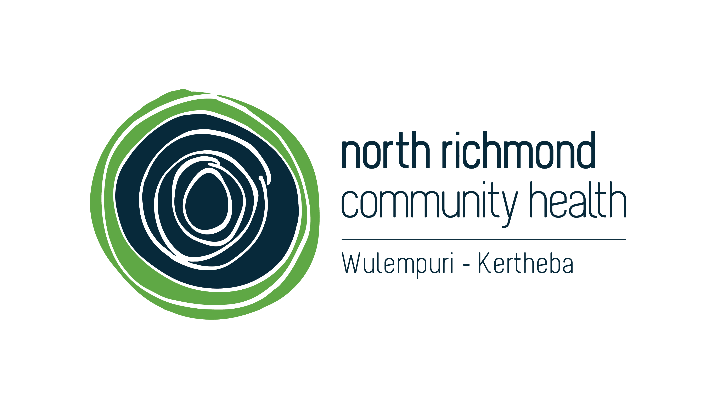

Community health, safety and wellbeing in Richmond

Information for local residents, traders and visitors

Request disposal of discarded needle syringes and related litter
If you find a needle syringe you can call and leave a message to have it collected within 24 hours.

Needles found in public spaces
Telephone: Yarra Syringe Disposal Hotline (03) 9417 5125
Email: yarrasyringe.disposal@cohealth.org.au

Needles found near North Richmond Community Health
Telephone: North Richmond Community Health (03) 9418 9800
9:00am – 5:00pm, Monday - Friday

Needles found on public housing grounds
Telephone: Richmond Local Housing Office (03) 9429 5174
24 hours a day, seven days a week

Neglected property, cleaning and maintenance
Requesting Yarra City Council cleaning and maintenance
You can help Yarra City Council maintain cleanliness by requesting a cleaning service or reporting maintenance issues such as graffiti removal, street cleaning, or damaged play equipment and park furniture.
Telephone: Yarra City Council (03) 9205 5555
Email: info@yarracity.vic.gov.au
Website: www.yarracity.vic.gov.au/cleaningrequests

Requesting Department of Health and Human Services public housing cleaning and maintenance
You can help the Department of Health and Human Services maintain public housing cleanliness by requesting a cleaning service or reporting maintenance issues to the Local Housing Office.
Telephone: Richmond Local Housing Office (03) 9429 5174
24 hours a day, seven days a week

Reporting graffiti
You are encouraged to contact the police when your property has been vandalised or graffitied. This ensures the police have accurate statistics about the level of vandalism and graffiti in the local area.
Street Address: 217 Church Street, Richmond, Victoria 3121
24 hours a day, seven days a week
Telephone: Victoria Police (03) 8420 3600

Emergency assistance
Please call Triple Zero (000) when an immediate response is required, if someone is in need of urgent medical help, in immediate danger or if a crime is happening.
Telephone: Triple Zero (000)
24 hours a day, seven days a week

Illegal activity and personal safety

Reporting crime or antisocial behaviour
If you have any information regarding a crime, criminal activity, or antisocial behaviour you can contact Crime Stoppers Victoria and confidentially report what you know.
Telephone: Crime Stoppers Victoria 1800 333 000
Website: www.crimestoppersvic.com.au/report-a-crime

Reporting non-emergency crime incidents
Contact your local police station via phone or in person to report non-emergency crime incidents.
Street Address: 217 Church Street, Richmond, Victoria 3121
24 hours a day, seven days a week
Telephone: Victoria Police (03) 8420 3600

Public injecting and drug affected people

Requesting daytime mobile drug safety and outreach workers
Telephone: North Richmond Community Health (03) 9418 9800
Monday - Friday: 9.00am to 5.00pm
Email: ourcentre@nrch.com.au

Requesting youth outreach workers
Telephone: Youth Support and Advocacy Service (YSAS) (03) 9415 1698
Tuesday - Thursday 12:00pm – 5.30pm, Friday 12:00pm – 7.30pm, Saturday 12:00pm – 8:00pm

Alcohol and other drug counselling, advice and referral

Requesting confidential alcohol and other drug information, advice, counselling and referral services
Telephone: Directline 1800 888 236
24 hours a day, seven days a week

Requesting youth alcohol and other drug information, advice, counselling and referral services
Telephone: Youth drug and alcohol advice service (YoDAA) 1800 458 685
9:00am – 8:00pm, Monday to Friday

